Welcome to KS5 Business Studies Essential work

Welcome to Business Studies, one of the most studied international subjects in the world. Business Studies opens the doors to study a range of specialist careers including accountancy, finance, human resource management or marketing. Studying Business will help you to appreciate the realities of managing a business including how to effectively manage and lead people, how to gain a competitive edge as an organisation and how to recognise the principles of success.

Overview of the course
This is a two-year course which involves you completing 2 examinations and 3 extensive pieces of coursework

Year 12 | Year 13
Unit 1 The Business Environment – exam  Unit 4 – Customers and communication - coursework  Unit 8– Introduction to Human Resources – coursework | Unit 2 – Working in Business- exam  Unit 17 – Responsible Business Practices – coursework

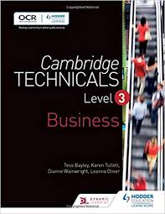

These are some tasks that will help you to prepare for
Unit 1: The Business Environment

Task 1

- Explain your understanding of both the private and public sector using examples to support your findings
- Find out what a Community Interest Company (CIC) is. Explain your understanding of this, including the advantages and disadvantages of setting up a business in this way.

Task 2 – Reporting Table

Research the following four different types of ownership a business may decide to operate as. This research should include:
- Sole Traders, Partnerships, Limited Companies (LTDs) and PLCs

- For all four business structures, I would like you to complete the table below

Structure | Advantages | Disadvantages
Sole Trader
Partnership
LTD business
PLC Business

Task 3
Choose something from the suggested Reading/ Watching /Listening list for Business Studies on the ‘Keep Learning’ document. Can you prepare to report on this in your first week in Business Studies? Your report can be with or without a visual aid. So, for example, which podcast /TedTalks did you listen to and what did you take/learn from it?
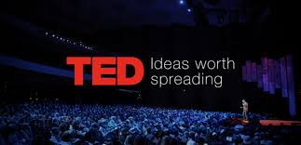
Task 4
Find and read articles related to the current inflationary issues in the UK. Can you find out:
- The meaning of the term ‘inflation’
- The causes of the current inflationary pressures in the UK
- How the Government are trying to tackle the issue

Task 5
Identify the financial and non-financial aims a business may have i.e. they may choose to make a profit or be seen as a more ethical company

Task 6
Find out what a stakeholder is and identify the different stakeholders a business may have. Explain what each one would want from a business

Finance

Businesses would struggle to survive if they were not on top of their Accounting. As much as many large businesses pay Accountants to manage their finances, often this can be a very costly process for SMEs (can you look up the meaning of SMEs)?

Unit 1 includes a significant element of Financial Accounting in the exam. This is not ‘Maths’, but is more about interpreting the accounts of a business and how they are performing.

There are three financial statements that if researched in advance of starting the course, would really help you to get ahead of the game:

- Income statements
- Statement of financial position
Cash flow forecasts

Unit 4 – Customers and communication

As well as working on Unit 1, you will start working on Unit 4 (coursework) as soon as you start the course in September. The coursework unit will be based on Wimbledon Common Golf Club, so if you can use their website to find out a bit more about them this will benefit you.

https://www.wcgc.co.uk/
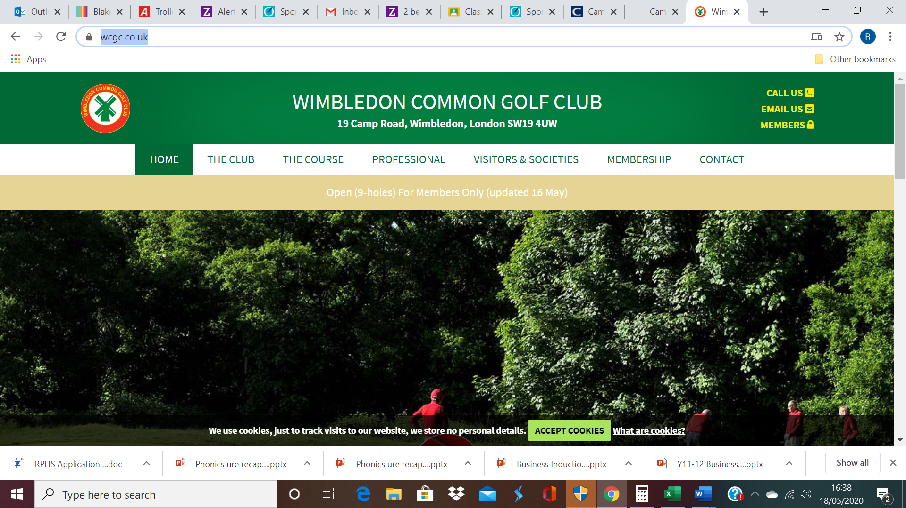

The type of information to research is:

- What does their website include?
- How do they use social media?
- How do their members sign up to join the club?
- What are your thoughts on communication and how they communicate with their members over their website or social media?

Before we visit the Golf club and conduct some in -depth research, we will need to understand some theory.

Demographics

To avoid having difficulties with understanding Demographics and how to discuss Demographics, you should research CACI’s Acorn UK demographics profile which includes subsections of the population from ‘affluent achievers’ down to the ‘hard-pressed’.

Task 7

Use the Investopedia website to search for a definition of the term demographics and write down all the possible ways that population could be classified ie age, gender, etc

Task 8

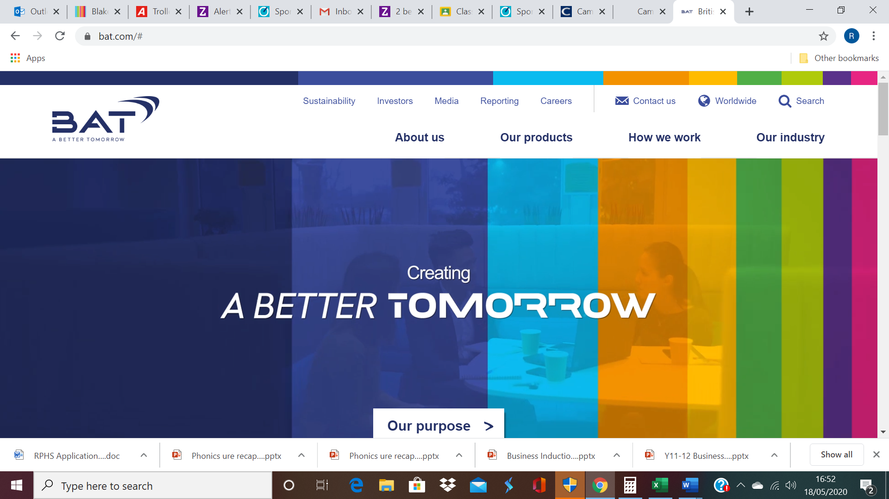

Look at the website for BAT (British American Tobacco) which outlines their corporate standards and then write down your thoughts on what you regard as a ‘corporate standard’. You may need to research this. Do not get confused with corporate profile.

Third sector organisations and customer service

Some businesses do not have profit as their main objective and instead seek to help a community or a certain sector of the population, e.g. Shelter is a charity to help the homeless and The Big Issue is a social enterprise which also helps the homeless but through trading rather than donations. Look at the website of The Big Issue and their video gallery.

The Big Issue Foundation https://www.bigissue.org.uk/ Their ‘About us’ page explains what The Big Issue is and how it aims to help the homeless through trade. The video gallery has short video clips about The Big Issue and how it helps the homeless through trade.
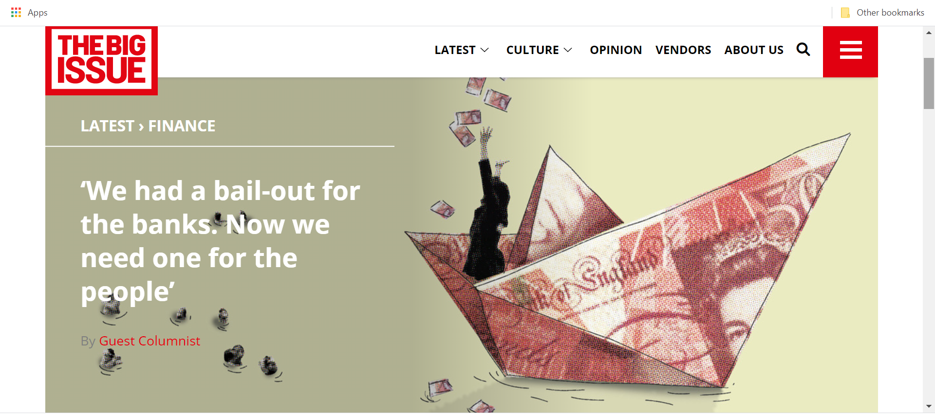

Task 9

Write a short report encompassing detail from The Big Issue and other enterprises you may come across in your research.

- How do these social enterprises use customer service to communicate their messages?
- How do they market/advertise their work?
- What makes them successful in their aim to support others?
- How do they raise funds?

