ONCE A SOCIOLOGIST, ALWAYS A SOCIOLOGIST!
The Sociology department would love for you to continue to stay cognitively engaged over the summer. The following are suggestions, they are not compulsory, but we would love for you to engage in any that you find interesting.
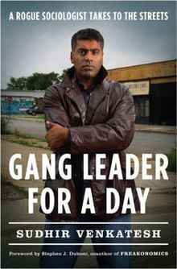
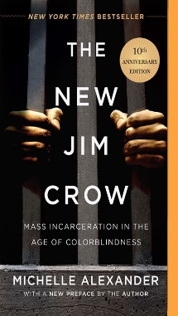
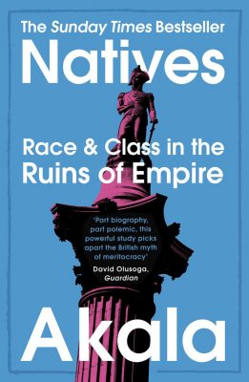
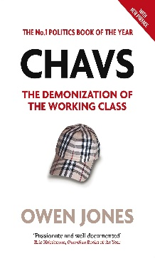

 | www.theguardian.com/education/sociology  www.nytimes.com/topic/subject/sociology  www.tutor2u.net/sociology/blog  www.nortonbooks.typepad.com/everydaysociology/  www.soc.washington.edu/news | www.sociologysal.blogspot.com  www.gendersociety.wordpress.com  www.creativesociology.blogspot.com  www.sociologylens.net  www.blogs.lse.ac.uk/impactofsocialsciences/

 | www.anchor.fm/allsociology  www.measureradio.libsyn.com/podcast  www.socialsciencespace.com/author/socialsciencebites | www.thesocialbreakdown.com  www.soundcloud.com/thesociologicalreview  www.bbc.co.uk/programmes/b006qy05  www.anchor.fm/digital-sociology-podcast

 | www.bbc.co.uk/programmes/topics/Sociology_of_culture  Black Mirror  www.channel4.com/programmes/dispatches | Poor Kids: Life on the Breadline (Child Poverty Documentary) | Real Stories  www.ted.com/talks?topics%5B%5D=sociology  BBC Panorama

